practice-3-dataanalysis.R
r1701177
2026-05-28
#--------------------start-------------------------------
# Get current working directory
getwd()
## [1] "/cloud/project"
#----------------read dataset--------------------------
data_for_analysis<-read.csv("data_for_analysis.csv")
#-----------descriptive statistics------------------
summary(data_for_analysis)
## record_id outcome factor_eth factor_h factor_pcos
## Min. : 1 Min. :0.0000 Min. :1.00 Min. :0.000 Min. :1.0
## 1st Qu.: 655 1st Qu.:0.0000 1st Qu.:1.00 1st Qu.:0.000 1st Qu.:1.0
## Median :1258 Median :0.0000 Median :1.00 Median :0.000 Median :3.0
## Mean :1306 Mean :0.1395 Mean :1.46 Mean :0.194 Mean :2.6
## 3rd Qu.:1946 3rd Qu.:0.0000 3rd Qu.:2.00 3rd Qu.:0.000 3rd Qu.:4.0
## Max. :2694 Max. :1.0000 Max. :3.00 Max. :1.000 Max. :4.0
## NAs :1 NAs :1 NAs :14 NAs :983
## factor_prl hormone1 hormone2 hormone3
## Min. :0.00000 Min. : 0.050 Min. : 31.0 Min. : 0.000
## 1st Qu.:0.00000 1st Qu.: 1.100 1st Qu.: 227.0 1st Qu.: 3.500
## Median :0.00000 Median : 1.500 Median : 317.0 Median : 5.700
## Mean :0.06708 Mean : 1.801 Mean : 380.2 Mean : 9.115
## 3rd Qu.:0.00000 3rd Qu.: 2.100 3rd Qu.: 457.0 3rd Qu.: 9.500
## Max. :1.00000 Max. :26.100 Max. :2798.0 Max. :118.400
## NAs :15
## hormone4 hormone5 hormone6 hormone7
## Min. : 0.100 Min. : 0.0 Min. : 0.76 Min. : 0.000
## 1st Qu.: 3.800 1st Qu.: 179.3 1st Qu.: 40.58 1st Qu.: 2.600
## Median : 5.500 Median : 270.5 Median : 64.85 Median : 5.100
## Mean : 7.771 Mean : 327.5 Mean : 78.45 Mean : 5.628
## 3rd Qu.: 7.400 3rd Qu.: 378.8 3rd Qu.:100.97 3rd Qu.: 7.600
## Max. :131.400 Max. :5686.8 Max. :375.20 Max. :47.100
##
## hormone8 hormone10_generated lipids1 lipids2
## Min. : 16.3 Min. : 0.0770 Min. :0.2000 Min. :2.430
## 1st Qu.:115.8 1st Qu.: 0.2860 1st Qu.:0.6875 1st Qu.:3.840
## Median :162.0 Median : 0.4310 Median :0.9200 Median :4.390
## Mean :176.3 Mean : 0.7258 Mean :0.9610 Mean :4.504
## 3rd Qu.:218.0 3rd Qu.: 0.6380 3rd Qu.:1.1800 3rd Qu.:5.040
## Max. :558.0 Max. :261.0000 Max. :2.7300 Max. :8.820
##
## lipids3 lipids4 lipids5 сarb_metabolism
## Min. :0.410 Min. :0.820 Min. :0.0900 Min. : 3.040
## 1st Qu.:0.920 1st Qu.:2.330 1st Qu.:0.3000 1st Qu.: 4.300
## Median :1.070 Median :2.840 Median :0.4200 Median : 4.800
## Mean :1.106 Mean :2.966 Mean :0.4333 Mean : 4.889
## 3rd Qu.:1.270 3rd Qu.:3.442 3rd Qu.:0.5400 3rd Qu.: 5.380
## Max. :2.010 Max. :7.010 Max. :1.2400 Max. :11.500
## NAs :276
## lipid_pero1 lipid_pero2 lipid_pero3 lipid_pero4
## Min. :0.500 Min. :0.120 Min. :0.0700 Min. : 0.23
## 1st Qu.:1.510 1st Qu.:0.980 1st Qu.:0.4075 1st Qu.: 0.93
## Median :1.980 Median :1.300 Median :0.6000 Median : 1.33
## Mean :2.084 Mean :1.393 Mean :0.6916 Mean : 1.44
## 3rd Qu.:2.562 3rd Qu.:1.700 3rd Qu.:0.9125 3rd Qu.: 1.80
## Max. :5.020 Max. :3.700 Max. :1.9300 Max. :12.40
##
## lipid_pero5 antioxidant1 antioxidant2 antioxidant3
## Min. : 1.750 Min. :1.070 Min. :1.18 Min. :0.940
## 1st Qu.: 9.277 1st Qu.:1.480 1st Qu.:2.00 1st Qu.:1.730
## Median :11.725 Median :1.630 Median :2.31 Median :1.950
## Mean :11.864 Mean :1.621 Mean :2.34 Mean :1.973
## 3rd Qu.:14.360 3rd Qu.:1.760 3rd Qu.:2.61 3rd Qu.:2.180
## Max. :27.800 Max. :2.430 Max. :3.82 Max. :3.590
##
## antioxidant4 antioxidant5
## Min. : 0.000 Min. :0.2300
## 1st Qu.: 5.460 1st Qu.:0.4800
## Median : 7.340 Median :0.6200
## Mean : 7.853 Mean :0.6922
## 3rd Qu.: 9.680 3rd Qu.:0.8400
## Max. :25.000 Max. :2.0400
##
#-----------for publication tables-----------------
#---------------Creating a custom table--------------
# Homework: Creating a custom table with descriptive statistics results
#install.packages("gtsummary")
#install.packages(c("cardx", "cards"))
#library(cardx)
#library(gtsummary)
#tbl_summary(data_for_analysis) # Automatic table
#tbl_summary(data_for_analysis, by = outcome) # By groups
#--------------Statistical Tests---------------------
value_outcome1<-data_for_analysis[data_for_analysis$outcome=="1",]$lipids1
hist(value_outcome1, col = "lightblue")
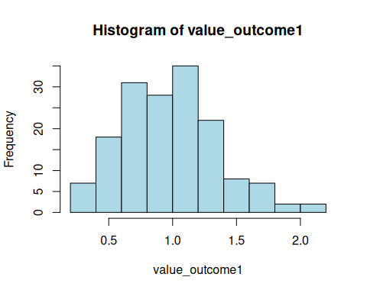
qqnorm(value_outcome1, main = "Q-Q Plot")
qqline(value_outcome1, col = "red", lwd = 2)
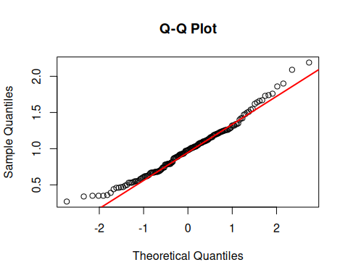
# Shapiro-Wilk test (for n < 5000)
shapiro.test(value_outcome1)
##
## Shapiro-Wilk normality test
##
## data: value_outcome1
## W = 0.97772, p-value = 0.01093
value_outcome0<-data_for_analysis[data_for_analysis$outcome=="0",]$lipids1
hist(value_outcome0, col = "lightgreen")
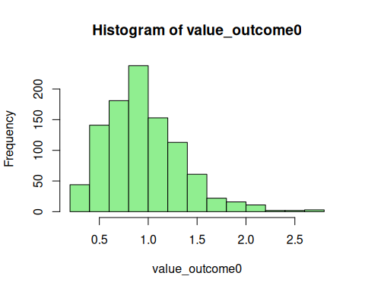
qqnorm(value_outcome0, main = "Q-Q Plot")
qqline(value_outcome0, col = "red", lwd = 2)
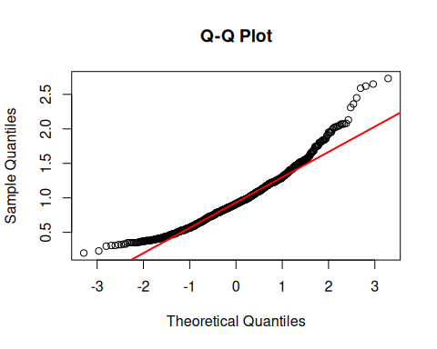
# Shapiro-Wilk test (for n < 5000)
shapiro.test(value_outcome0)
##
## Shapiro-Wilk normality test
##
## data: value_outcome0
## W = 0.9536, p-value < 2.2e-16
#-------Levene's Test for Homogeneity of Variance--------------
install.packages("car")
## Installing package into '/cloud/lib/x86_64-pc-linux-gnu-library/4.6'
## (as 'lib' is unspecified)
library(car)
## Loading required package: carData
str(data_for_analysis)
## 'data.frame': 1148 obs. of 31 variables:
## $ record_id : int 1 2 3 4 6 8 9 10 12 13 ...
## $ outcome : int 0 0 0 0 0 1 0 1 1 0 ...
## $ factor_eth : int 1 1 1 1 1 1 1 1 1 2 ...
## $ factor_h : int 0 0 0 0 0 0 0 1 0 1 ...
## $ factor_pcos : int NA NA NA NA NA NA NA NA NA 1 ...
## $ factor_prl : int 0 0 0 0 0 0 0 0 0 0 ...
## $ hormone1 : num 0.5 1.9 1.2 3.8 1.6 1.6 0.42 2.7 1 1.8 ...
## $ hormone2 : int 314 196 311 409 418 309 415 450 198 569 ...
## $ hormone3 : num 9.9 6.8 1.2 3.2 3.8 2.7 5.9 7 9 20.6 ...
## $ hormone4 : num 4.2 6.8 3.2 2.7 7.2 1.6 9.1 4.5 5.2 8.3 ...
## $ hormone5 : num 322.7 190.9 153.7 225.7 99.9 ...
## $ hormone6 : num 166.1 41 140.8 93.4 24.7 ...
## $ hormone7 : num 5.7 6.8 5.4 12.7 1.6 9.9 7.5 4 4.2 1.7 ...
## $ hormone8 : num 129 260 81.1 148 121 120 135 199 149 238 ...
## $ hormone10_generated: num 0.922 0.166 0.405 0.441 0.199 ...
## $ lipids1 : num 0.4 0.54 0.45 0.38 0.48 0.34 0.49 0.62 1.1 0.51 ...
## $ lipids2 : num 5.05 3.9 3.5 4.84 3.96 3.85 3.93 4.3 3.89 3.72 ...
## $ lipids3 : num 1.23 1.67 1.29 1.32 1.85 1.42 1.26 1.3 1.11 0.78 ...
## $ lipids4 : num 3.64 1.98 2.01 3.35 1.89 2.28 2.45 2.72 2.28 2.28 ...
## $ lipids5 : num 0.18 0.25 0.2 0.17 0.22 0.15 0.22 0.28 0.5 NA ...
## $ сarb_metabolism : num 5.41 4.5 5.57 5.95 4.15 4.66 4.44 5.32 4.71 4.39 ...
## $ lipid_pero1 : num 2.36 2.82 2.16 2.44 1.98 2.36 3.06 2.48 1.83 3.62 ...
## $ lipid_pero2 : num 1.56 1.36 0.72 1.86 0.86 1.17 1.64 1.22 1.35 1.26 ...
## $ lipid_pero3 : num 1.14 0.71 0.27 1.46 0.33 0.62 0.76 0.81 0.65 0.43 ...
## $ lipid_pero4 : num 0.87 1.51 0.64 1.32 2.04 2.61 1.77 0.58 0.39 2.02 ...
## $ lipid_pero5 : num 10.4 13.7 10.6 10.4 15.1 ...
## $ antioxidant1 : num 1.64 1.33 1.85 1.34 1.72 1.43 1.7 1.31 1.58 1.73 ...
## $ antioxidant2 : num 2.24 2.48 2.19 1.58 2.14 2.14 2.22 2.02 2.15 2.36 ...
## $ antioxidant3 : num 1.91 1.98 1.92 1.86 2.34 1.83 2.08 1.98 2.24 2.11 ...
## $ antioxidant4 : num 5.21 5.06 9.58 7.46 9.22 7.62 13 7.8 8.85 8.4 ...
## $ antioxidant5 : num 0.38 0.39 0.49 0.43 0.86 0.38 0.94 0.47 1.12 0.74 ...
data_for_analysis$outcome<- as.factor(data_for_analysis$outcome)
car::leveneTest(lipids1 ~ outcome, data = data_for_analysis)
## Levene's Test for Homogeneity of Variance (center = median)
## Df F value Pr(>F)
## group 1 0.0204 0.8866
## 1145
#---------------Application of the Brunner-Munzel test----------
install.packages("lawstat")
## Installing package into '/cloud/lib/x86_64-pc-linux-gnu-library/4.6'
## (as 'lib' is unspecified)
library(lawstat)
##
## Attaching package: 'lawstat'
## The following object is masked from 'package:car':
##
## levene.test
group1 <- data_for_analysis$lipids1[data_for_analysis$outcome == "0"]
group2 <- data_for_analysis$lipids1[data_for_analysis$outcome == "1"]
brunner.munzel.test(group1, group2)
##
## Brunner-Munzel Test
##
## data: group1 and group2
## Brunner-Munzel Test Statistic = 1.239, df = 214.4, p-value = 0.2167
## 95 percent confidence interval:
## 0.4819959 0.5789400
## sample estimates:
## P(X<Y)+.5*P(X=Y)
## 0.530468
#-------------comparison of results with other tests--------------
t.test(group1, group2)
##
## Welch Two Sample t-test
##
## data: group1 and group2
## t = -0.85984, df = 219.2, p-value = 0.3908
## alternative hypothesis: true difference in means is not equal to 0
## 95 percent confidence interval:
## -0.08994045 0.03530038
## sample estimates:
## mean of x mean of y
## 0.957305 0.984625
wilcox.test(group1, group2)
##
## Wilcoxon rank sum test with continuity correction
##
## data: group1 and group2
## W = 74148, p-value = 0.2158
## alternative hypothesis: true location shift is not equal to 0
#----------------------------EDA----------------------------------
install.packages("DataExplorer")
## Installing package into '/cloud/lib/x86_64-pc-linux-gnu-library/4.6'
## (as 'lib' is unspecified)
library(DataExplorer)
create_report(data_for_analysis) # Generates HTML report with graphs and statistics
##
##
## processing file: report.rmd
## | | | 0% | |. | 2% | |.. | 4% [global_options] | |.. | 7% | |... | 9% [introduce] | |.... | 11% | |..... | 13% [plot_intro]
## | |...... | 15% | |...... | 17% [data_structure] | |....... | 20% | |........ | 22% [missing_profile]
## | |......... | 24% | |.......... | 26% [univariate_distribution_header] | |.......... | 28% | |........... | 30% [plot_histogram]
## | |............ | 33% | |............. | 35% [plot_response_histogram] | |.............. | 37% | |.............. | 39% [plot_density] | |............... | 41% | |................ | 43% [plot_response_density] | |................. | 46% | |.................. | 48% [plot_frequency_bar]
## | |.................. | 50% | |................... | 52% [plot_response_bar] | |.................... | 54% | |..................... | 57% [plot_with_bar] | |...................... | 59% | |....................... | 61% [plot_normal_qq]
## | |....................... | 63% | |........................ | 65% [plot_response_qq] | |......................... | 67% | |.......................... | 70% [plot_by_qq] | |........................... | 72% | |........................... | 74% [correlation_analysis]
## | |............................ | 76% | |............................. | 78% [principal_component_analysis]
## | |.............................. | 80% | |............................... | 83% [bivariate_distribution_header] | |............................... | 85% | |................................ | 87% [plot_response_boxplot] | |................................. | 89% | |.................................. | 91% [plot_by_boxplot] | |................................... | 93% | |................................... | 96% [plot_response_scatterplot] | |.................................... | 98% | |.....................................| 100% [plot_by_scatterplot]
## output file: /cloud/project/report.knit.md
## /usr/lib/rstudio-server/bin/quarto/bin/tools/x86_64/pandoc +RTS -K512m -RTS /cloud/project/report.knit.md --to html4 --from markdown+autolink_bare_uris+tex_math_single_backslash --output /cloud/project/report.html --lua-filter /cloud/lib/x86_64-pc-linux-gnu-library/4.6/rmarkdown/rmarkdown/lua/pagebreak.lua --lua-filter /cloud/lib/x86_64-pc-linux-gnu-library/4.6/rmarkdown/rmarkdown/lua/latex-div.lua --lua-filter /cloud/lib/x86_64-pc-linux-gnu-library/4.6/rmarkdown/rmarkdown/lua/table-classes.lua --embed-resources --standalone --variable bs3=TRUE --section-divs --table-of-contents --toc-depth 6 --template /cloud/lib/x86_64-pc-linux-gnu-library/4.6/rmarkdown/rmd/h/default.html --no-highlight --variable highlightjs=1 --variable theme=yeti --mathjax --variable 'mathjax-url=https://mathjax.rstudio.com/latest/MathJax.js?config=TeX-AMS-MML_HTMLorMML' --include-in-header /tmp/Rtmp70KYPM/rmarkdown-stre4a39e34d68.html
##
## Output created: report.html
create_report(
data = data_for_analysis,
output_file = "EDA_Report.html",
output_dir = getwd(),
report_title = "EDA Report"
)
##
##
## processing file: report.rmd
## | | | 0% | |. | 2% | |.. | 4% [global_options] | |.. | 7% | |... | 9% [introduce] | |.... | 11% | |..... | 13% [plot_intro]
## | |...... | 15% | |...... | 17% [data_structure] | |....... | 20% | |........ | 22% [missing_profile]
## | |......... | 24% | |.......... | 26% [univariate_distribution_header] | |.......... | 28% | |........... | 30% [plot_histogram]
## | |............ | 33% | |............. | 35% [plot_response_histogram] | |.............. | 37% | |.............. | 39% [plot_density] | |............... | 41% | |................ | 43% [plot_response_density] | |................. | 46% | |.................. | 48% [plot_frequency_bar]
## | |.................. | 50% | |................... | 52% [plot_response_bar] | |.................... | 54% | |..................... | 57% [plot_with_bar] | |...................... | 59% | |....................... | 61% [plot_normal_qq]
## | |....................... | 63% | |........................ | 65% [plot_response_qq] | |......................... | 67% | |.......................... | 70% [plot_by_qq] | |........................... | 72% | |........................... | 74% [correlation_analysis]
## | |............................ | 76% | |............................. | 78% [principal_component_analysis]
## | |.............................. | 80% | |............................... | 83% [bivariate_distribution_header] | |............................... | 85% | |................................ | 87% [plot_response_boxplot] | |................................. | 89% | |.................................. | 91% [plot_by_boxplot] | |................................... | 93% | |................................... | 96% [plot_response_scatterplot] | |.................................... | 98% | |.....................................| 100% [plot_by_scatterplot]
## output file: /cloud/project/report.knit.md
## /usr/lib/rstudio-server/bin/quarto/bin/tools/x86_64/pandoc +RTS -K512m -RTS /cloud/project/report.knit.md --to html4 --from markdown+autolink_bare_uris+tex_math_single_backslash --output /cloud/project/EDA_Report.html --lua-filter /cloud/lib/x86_64-pc-linux-gnu-library/4.6/rmarkdown/rmarkdown/lua/pagebreak.lua --lua-filter /cloud/lib/x86_64-pc-linux-gnu-library/4.6/rmarkdown/rmarkdown/lua/latex-div.lua --lua-filter /cloud/lib/x86_64-pc-linux-gnu-library/4.6/rmarkdown/rmarkdown/lua/table-classes.lua --embed-resources --standalone --variable bs3=TRUE --section-divs --table-of-contents --toc-depth 6 --template /cloud/lib/x86_64-pc-linux-gnu-library/4.6/rmarkdown/rmd/h/default.html --no-highlight --variable highlightjs=1 --variable theme=yeti --mathjax --variable 'mathjax-url=https://mathjax.rstudio.com/latest/MathJax.js?config=TeX-AMS-MML_HTMLorMML' --include-in-header /tmp/Rtmp70KYPM/rmarkdown-stre4a3a19c7e9.html
##
## Output created: EDA_Report.html
# Load required libraries
library(car)
library(lawstat)
library(dplyr)
##
## Attaching package: 'dplyr'
## The following objects are masked from 'package:data.table':
##
## between, first, last
## The following object is masked from 'package:car':
##
## recode
## The following objects are masked from 'package:stats':
##
## filter, lag
## The following objects are masked from 'package:base':
##
## intersect, setdiff, setequal, union
library(knitr)
# Convert outcome to factor
data_for_analysis$outcome <- as.factor(data_for_analysis$outcome)
# List of hormone variables (all hormone columns)
hormone_vars <- c("hormone1", "hormone2", "hormone3", "hormone4", "hormone5",
"hormone6", "hormone7", "hormone8", "hormone10_generated")
# Create descriptive statistics table
descriptives_table <- function(data, vars, group_var) {
results <- data.frame()
for(var in vars) {
# Group 0 (outcome = 0)
group0 <- data[data[[group_var]] == "0", var]
group0_clean <- group0[!is.na(group0)]
# Group 1 (outcome = 1)
group1 <- data[data[[group_var]] == "1", var]
group1_clean <- group1[!is.na(group1)]
# Shapiro-Wilk tests
shapiro0 <- if(length(group0_clean) >= 3 & length(group0_clean) <= 5000)
shapiro.test(group0_clean)$p.value else NA
shapiro1 <- if(length(group1_clean) >= 3 & length(group1_clean) <= 5000)
shapiro.test(group1_clean)$p.value else NA
# Determine distribution type (normal if p > 0.05)
dist0 <- ifelse(!is.na(shapiro0) & shapiro0 > 0.05, "Normal", "Non-normal")
dist1 <- ifelse(!is.na(shapiro1) & shapiro1 > 0.05, "Normal", "Non-normal")
# Calculate statistics
row <- data.frame(
Hormone = var,
# Group 0 (outcome=0)
n0 = length(group0_clean),
Mean0 = round(mean(group0_clean, na.rm = TRUE), 3),
SD0 = round(sd(group0_clean, na.rm = TRUE), 3),
Median0 = round(median(group0_clean, na.rm = TRUE), 3),
IQR0 = round(IQR(group0_clean, na.rm = TRUE), 3),
Distribution0 = dist0,
Shapiro_p0 = round(shapiro0, 4),
# Group 1 (outcome=1)
n1 = length(group1_clean),
Mean1 = round(mean(group1_clean, na.rm = TRUE), 3),
SD1 = round(sd(group1_clean, na.rm = TRUE), 3),
Median1 = round(median(group1_clean, na.rm = TRUE), 3),
IQR1 = round(IQR(group1_clean, na.rm = TRUE), 3),
Distribution1 = dist1,
Shapiro_p1 = round(shapiro1, 4)
)
results <- rbind(results, row)
}
return(results)
}
# Generate table
hormone_desc_table <- descriptives_table(data_for_analysis, hormone_vars, "outcome")
print(hormone_desc_table)
## Hormone n0 Mean0 SD0 Median0 IQR0 Distribution0
## 1 hormone1 987 1.824 1.580 1.500 1.000 Non-normal
## 2 hormone2 987 375.148 255.411 312.000 226.500 Non-normal
## 3 hormone3 987 8.991 11.582 5.600 6.000 Non-normal
## 4 hormone4 987 7.508 10.922 5.500 3.500 Non-normal
## 5 hormone5 987 335.608 332.255 274.898 197.219 Non-normal
## 6 hormone6 987 78.890 53.989 64.500 60.400 Non-normal
## 7 hormone7 987 5.625 3.899 5.100 4.900 Non-normal
## 8 hormone8 987 180.020 87.230 166.000 102.000 Non-normal
## 9 hormone10_generated 987 0.762 8.298 0.427 0.355 Non-normal
## Shapiro_p0 n1 Mean1 SD1 Median1 IQR1 Distribution1 Shapiro_p1
## 1 0 160 1.658 0.862 1.500 0.900 Non-normal 0e+00
## 2 0 160 411.956 270.886 365.500 235.000 Non-normal 0e+00
## 3 0 160 9.911 11.790 6.050 6.675 Non-normal 0e+00
## 4 0 160 9.401 13.436 5.500 4.600 Non-normal 0e+00
## 5 0 160 276.449 235.445 250.000 194.767 Non-normal 0e+00
## 6 0 160 75.754 48.684 68.700 63.525 Non-normal 0e+00
## 7 0 160 5.650 3.970 5.100 5.250 Non-normal 0e+00
## 8 0 160 153.762 70.964 142.500 97.250 Non-normal 1e-04
## 9 0 160 0.508 0.366 0.456 0.324 Non-normal 0e+00
#2
# Perform Levene's test and Shapiro-Wilk test for all hormones
hormone_test_results <- data.frame()
for(var in hormone_vars) {
# Levene's test for homogeneity of variance
levene_result <- leveneTest(as.formula(paste(var, "~ outcome")), data = data_for_analysis)
# Shapiro-Wilk test for each group
group0 <- data_for_analysis[data_for_analysis$outcome == "0", var]
group1 <- data_for_analysis[data_for_analysis$outcome == "1", var]
shapiro0 <- if(sum(!is.na(group0)) >= 3) shapiro.test(group0)$p.value else NA
shapiro1 <- if(sum(!is.na(group1)) >= 3) shapiro.test(group1)$p.value else NA
hormone_test_results <- rbind(hormone_test_results, data.frame(
Hormone = var,
Levene_F = round(levene_result$`F value`[1], 4),
Levene_p = round(levene_result$`Pr(>F)`[1], 4),
Shapiro_p0 = round(shapiro0, 4),
Shapiro_p1 = round(shapiro1, 4)
))
}
print(hormone_test_results)
## Hormone Levene_F Levene_p Shapiro_p0 Shapiro_p1
## 1 hormone1 2.9375 0.0868 0 0e+00
## 2 hormone2 0.0007 0.9787 0 0e+00
## 3 hormone3 0.3106 0.5774 0 0e+00
## 4 hormone4 3.4640 0.0630 0 0e+00
## 5 hormone5 1.9278 0.1653 0 0e+00
## 6 hormone6 0.3877 0.5336 0 0e+00
## 7 hormone7 0.0650 0.7988 0 0e+00
## 8 hormone8 3.2666 0.0710 0 1e-04
## 9 hormone10_generated 0.1582 0.6909 0 0e+00
# Set up plotting parameters
par(mfrow = c(2, 2), mar = c(4, 4, 3, 2))
# Function to create histograms and Q-Q plots for each hormone
plot_diagnostics <- function(data, hormone_name) {
group0 <- data[data$outcome == "0", hormone_name]
group1 <- data[data$outcome == "1", hormone_name]
# Histogram for outcome=0
hist(group0, main = paste(hormone_name, "- Outcome=0"),
xlab = hormone_name, col = "lightblue", border = "white",
breaks = 20, freq = FALSE)
lines(density(group0, na.rm = TRUE), col = "red", lwd = 2)
# Q-Q plot for outcome=0
qqnorm(group0, main = paste(hormone_name, "- Q-Q Plot (Outcome=0)"))
qqline(group0, col = "red", lwd = 2)
# Histogram for outcome=1
hist(group1, main = paste(hormone_name, "- Outcome=1"),
xlab = hormone_name, col = "lightgreen", border = "white",
breaks = 20, freq = FALSE)
lines(density(group1, na.rm = TRUE), col = "red", lwd = 2)
# Q-Q plot for outcome=1
qqnorm(group1, main = paste(hormone_name, "- Q-Q Plot (Outcome=1)"))
qqline(group1, col = "red", lwd = 2)
}
# Generate plots for all hormones
for(hormone in hormone_vars) {
plot_diagnostics(data_for_analysis, hormone)
}
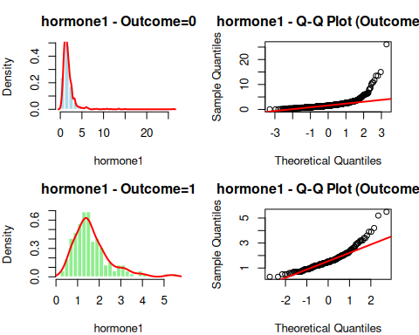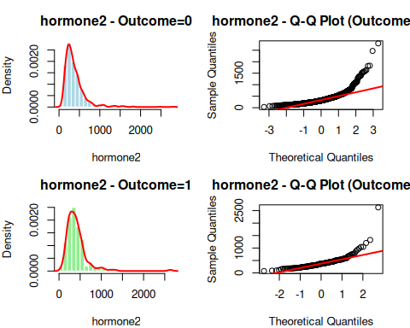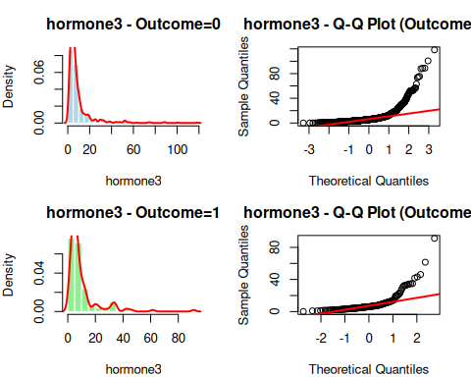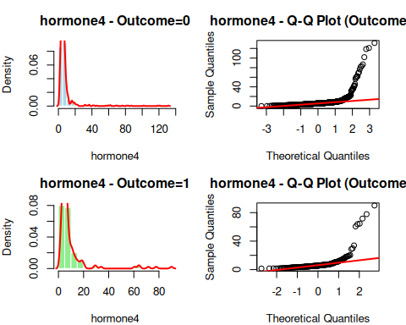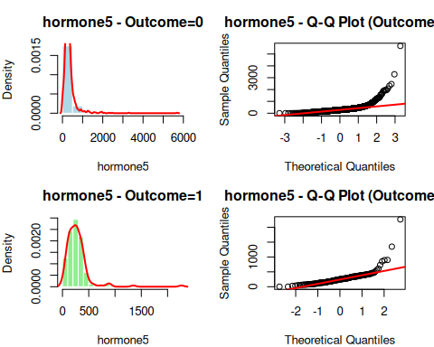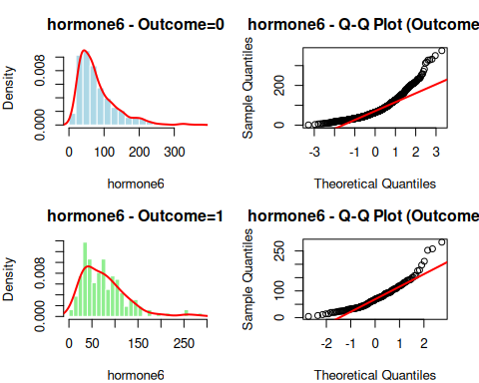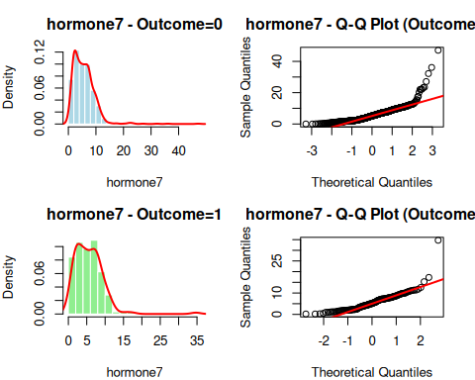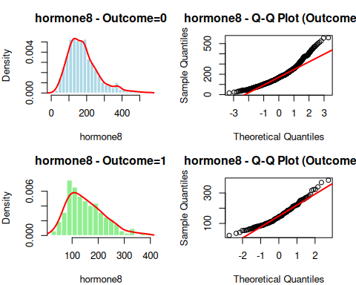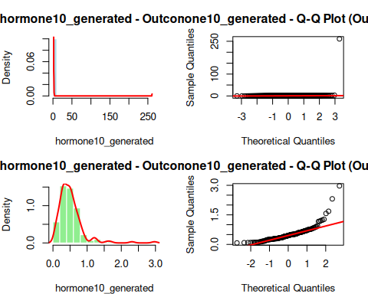
# Function to perform all three tests for a given variable
compare_tests <- function(data, var_name) {
group0 <- data[data$outcome == "0", var_name]
group1 <- data[data$outcome == "1", var_name]
# Remove NAs
group0 <- group0[!is.na(group0)]
group1 <- group1[!is.na(group1)]
# Brunner-Munzel test (robust to non-normality and heteroscedasticity)
bm_test <- tryCatch({
brunner.munzel.test(group0, group1)
}, error = function(e) list(p.value = NA))
# t-test (parametric, assumes normality)
t_test <- t.test(group0, group1)
# Wilcoxon rank-sum test (non-parametric)
wilcox_test <- wilcox.test(group0, group1)
return(data.frame(
Hormone = var_name,
Brunner_Munzel_p = round(bm_test$p.value, 5),
t_test_p = round(t_test$p.value, 5),
Wilcoxon_p = round(wilcox_test$p.value, 5)
))
}
# Perform tests for all hormones
all_test_results <- data.frame()
for(hormone in hormone_vars) {
all_test_results <- rbind(all_test_results, compare_tests(data_for_analysis, hormone))
}
print(all_test_results)
## Hormone Brunner_Munzel_p t_test_p Wilcoxon_p
## 1 hormone1 0.74996 0.05132 0.75867
## 2 hormone2 0.00359 0.10960 0.00540
## 3 hormone3 0.13068 0.35989 0.13459
## 4 hormone4 0.16351 0.09181 0.14821
## 5 hormone5 0.00304 0.00611 0.00372
## 6 hormone6 0.81730 0.45773 0.81599
## 7 hormone7 0.92198 0.94155 0.92058
## 8 hormone8 0.00038 0.00004 0.00038
## 9 hormone10_generated 0.78861 0.34035 0.79052
# Load required libraries
install.packages("corrplot")
## Installing package into '/cloud/lib/x86_64-pc-linux-gnu-library/4.6'
## (as 'lib' is unspecified)
library(corrplot)
## corrplot 0.95 loaded
library(ggplot2)
# Load library
library(corrplot)
# Calculate correlation matrices (Spearman for non-normal data)
data_outcome0 <- data_for_analysis[data_for_analysis$outcome == "0", hormone_vars]
data_outcome1 <- data_for_analysis[data_for_analysis$outcome == "1", hormone_vars]
cor_matrix0 <- cor(data_outcome0, method = "spearman", use = "pairwise.complete.obs")
cor_matrix1 <- cor(data_outcome1, method = "spearman", use = "pairwise.complete.obs")
# Create high-quality PDF
pdf("Correlation_Heatmaps.pdf", width = 14, height = 7)
par(mfrow = c(1, 2), mar = c(1, 1, 4, 1))
# Outcome = 0
corrplot(cor_matrix0,
method = "color",
type = "upper",
order = "hclust",
tl.col = "black",
tl.srt = 45,
tl.cex = 0.9,
title = "Outcome = 0 (Spearman)",
mar = c(0, 0, 5, 0),
diag = FALSE,
col = colorRampPalette(c("#313695", "#4575B4", "#74ADD1", "#ABD9E9",
"#E0F3F8", "#FFFFBF", "#FEE090", "#FDAE61",
"#F46D43", "#D73027", "#A50026"))(100),
addCoef.col = "black",
number.cex = 0.7,
cl.cex = 0.8)
# Outcome = 1
corrplot(cor_matrix1,
method = "color",
type = "upper",
order = "hclust",
tl.col = "black",
tl.srt = 45,
tl.cex = 0.9,
title = "Outcome = 1 (Spearman)",
mar = c(0, 0, 5, 0),
diag = FALSE,
col = colorRampPalette(c("#313695", "#4575B4", "#74ADD1", "#ABD9E9",
"#E0F3F8", "#FFFFBF", "#FEE090", "#FDAE61",
"#F46D43", "#D73027", "#A50026"))(100),
addCoef.col = "black",
number.cex = 0.7,
cl.cex = 0.8)
dev.off()
## png
## 2
# Print correlation matrices
print(round(cor_matrix0, 3))
## hormone1 hormone2 hormone3 hormone4 hormone5 hormone6
## hormone1 1.000 0.174 0.001 0.025 -0.066 -0.056
## hormone2 0.174 1.000 0.092 -0.004 0.019 0.026
## hormone3 0.001 0.092 1.000 0.587 0.251 -0.091
## hormone4 0.025 -0.004 0.587 1.000 0.071 -0.067
## hormone5 -0.066 0.019 0.251 0.071 1.000 0.069
## hormone6 -0.056 0.026 -0.091 -0.067 0.069 1.000
## hormone7 0.067 0.168 -0.007 -0.323 0.145 0.114
## hormone8 -0.011 0.011 0.030 -0.031 0.254 -0.156
## hormone10_generated -0.020 0.174 0.040 -0.140 -0.011 0.046
## hormone7 hormone8 hormone10_generated
## hormone1 0.067 -0.011 -0.020
## hormone2 0.168 0.011 0.174
## hormone3 -0.007 0.030 0.040
## hormone4 -0.323 -0.031 -0.140
## hormone5 0.145 0.254 -0.011
## hormone6 0.114 -0.156 0.046
## hormone7 1.000 0.088 0.190
## hormone8 0.088 1.000 -0.054
## hormone10_generated 0.190 -0.054 1.000
print(round(cor_matrix1, 3))
## hormone1 hormone2 hormone3 hormone4 hormone5 hormone6
## hormone1 1.000 0.213 -0.056 -0.024 -0.020 0.006
## hormone2 0.213 1.000 0.180 0.025 0.044 -0.114
## hormone3 -0.056 0.180 1.000 0.564 0.231 -0.050
## hormone4 -0.024 0.025 0.564 1.000 -0.058 0.107
## hormone5 -0.020 0.044 0.231 -0.058 1.000 0.142
## hormone6 0.006 -0.114 -0.050 0.107 0.142 1.000
## hormone7 -0.038 0.108 -0.048 -0.352 0.231 0.173
## hormone8 -0.134 -0.021 0.063 -0.020 0.250 -0.145
## hormone10_generated 0.071 0.118 0.130 -0.169 0.216 -0.025
## hormone7 hormone8 hormone10_generated
## hormone1 -0.038 -0.134 0.071
## hormone2 0.108 -0.021 0.118
## hormone3 -0.048 0.063 0.130
## hormone4 -0.352 -0.020 -0.169
## hormone5 0.231 0.250 0.216
## hormone6 0.173 -0.145 -0.025
## hormone7 1.000 0.136 0.269
## hormone8 0.136 1.000 0.057
## hormone10_generated 0.269 0.057 1.000
# Combine all results into a comprehensive table
final_results <- merge(hormone_test_results, all_test_results, by = "Hormone")
final_results <- merge(hormone_desc_table[, c("Hormone", "Distribution0", "Distribution1")],
final_results, by = "Hormone")
print(final_results)
## Hormone Distribution0 Distribution1 Levene_F Levene_p Shapiro_p0
## 1 hormone1 Non-normal Non-normal 2.9375 0.0868 0
## 2 hormone10_generated Non-normal Non-normal 0.1582 0.6909 0
## 3 hormone2 Non-normal Non-normal 0.0007 0.9787 0
## 4 hormone3 Non-normal Non-normal 0.3106 0.5774 0
## 5 hormone4 Non-normal Non-normal 3.4640 0.0630 0
## 6 hormone5 Non-normal Non-normal 1.9278 0.1653 0
## 7 hormone6 Non-normal Non-normal 0.3877 0.5336 0
## 8 hormone7 Non-normal Non-normal 0.0650 0.7988 0
## 9 hormone8 Non-normal Non-normal 3.2666 0.0710 0
## Shapiro_p1 Brunner_Munzel_p t_test_p Wilcoxon_p
## 1 0e+00 0.74996 0.05132 0.75867
## 2 0e+00 0.78861 0.34035 0.79052
## 3 0e+00 0.00359 0.10960 0.00540
## 4 0e+00 0.13068 0.35989 0.13459
## 5 0e+00 0.16351 0.09181 0.14821
## 6 0e+00 0.00304 0.00611 0.00372
## 7 0e+00 0.81730 0.45773 0.81599
## 8 0e+00 0.92198 0.94155 0.92058
## 9 1e-04 0.00038 0.00004 0.00038

